UNIVERSITY OF RWANDA

COLLEGE OF SCIENCE AND TECHNOLOGY SCHOOL OF ICT

COMPUTER AND SOFTWARE ENGINEERING DEPARTMENT NYARUGENGE CAMPUS
MODULE CODE/TITLE: WEB DESIGN

AGRICONNECT RWANDA

225061402
Year of study:YEAR 1
Date: 18 JULY 2026

Project Technical Report- Web Technology TECHNICAL ASSESSMENT 2026

Table of contents

Chapter 1. Introduction

Chapter 2. System Analysis and Design

Chapter 3. Implementation

Chapter 4. Conclusion and Recommendation

Appendix.

Table of Figures
2.2.1.1 HIGH-LEVEL ARCHITECTURE
2.2.2.1 UI DESIGN
    - Database design with ERD and relationships
3.2.1HOME PAGE
3.2.2REGISTER INFORMATION
3.2.3USER DASHBOARD
3.2.4ADMIN LOGIN

List of Abbreviations
No abbreviations I have used

Chapter 1. Introduction
1.1Historical background
Agriculture is a key sector in Rwanda, but farmers face challenges such as limited market access, poor transportation, and lack of timely agricultural advice. To address these issues, AgriConnect Rwanda was developed as a web-based platform that connects farmers, buyers, transport providers, and agricultural experts to improve communication and agricultural business.
  - Problem statement
Farmers struggle to find reliable buyers, buyers have difficulty locating trusted suppliers, and transport providers lack an organized system for receiving requests. In addition, farmers have limited access to expert advice. These challenges highlight the need for a centralized digital platform.
1.3 objectives of my project
General Objective:
- To develop a web-based system that connects farmers, buyers, transport providers, and agricultural experts.
Specific Objectives:
- Allow farmers to advertise products online.
- Enable buyers to search and purchase products.
- Facilitate transport service requests.
- Connect farmers with agricultural experts.
- Provide an admin dashboard to manage the system.

  - Expected outcomes
• Improved market access for farmers.
• Better communication among all users.
• Efficient transport coordination.
• Easy access to agricultural advice.
• Improved record management.
• Increased productivity and income.
  - Project rationale
AgriConnect Rwanda helps modernize agriculture by reducing dependence on middlemen, improving market access, enhancing transportation services, and promoting the use of ICT in agriculture. The system benefits farmers, buyers, transport providers, agricultural experts, and supports Rwanda's digital transformation goals.

Chapter 2. System Analysis and Design
- 2.1. System Analysis
- System analysis of AgriConnect Rwanda identified challenges faced by farmers, buyers, transport providers, and experts, such as poor communication, limited market access, and coordination difficulties. The proposed web-based system connects these stakeholders on one platform to improve agricultural trading and logistics efficiency.
2.1.1 Intended users of the project

he AgriConnect Rwanda system is designed for the following users:
1. Farmers
- Register and log in to the system.
- Add, update, and manage agricultural products.
- Receive orders from buyers.
- Request transport services.
- Consult agricultural experts.
2. Buyers
- Create an account and log in.
- Browse and search available products.
- Place orders.
- Request transportation.
- Communicate with farmers.
3. Transport Providers
- Register their transport services.
- Receive transport requests.
- Accept or reject delivery requests.
- Update delivery status.
4. Agricultural Experts
- Register on the platform.
- Provide farming advice and recommendations.
- Answer farmers' questions.
- Share modern agricultural practices.
5. System Administrator
- Manage all user accounts.
- Approve or remove users if necessary.
- Manage products and categories.
- Monitor transport requests and orders.
- Generate reports and maintain system security.

2.1.2 Intended system partners
2.1.2 Intended System Partners
The success of AgriConnect Rwanda depends on collaboration with several partners:
- Farmers' Cooperatives – Encourage farmers to use the platform.
- Transport Companies – Provide logistics and delivery services.
- Agricultural Extension Officers – Offer technical farming support.
- MINAGRI (Ministry of Agriculture and Animal Resources) – Promote digital agriculture initiatives.
- Financial Institutions and Mobile Payment Providers – Facilitate secure online payments.
- ICT Service Providers – Support internet connectivity and system hosting.

- 2.2. System Design
    - High-Level Architecture
AGRICONNECT RWANDA
2.2.1.1 HIGH-LEVEL ARCHITECTURE

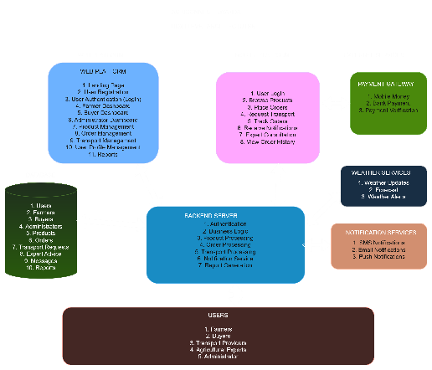
    - UI design (sketch of the UI module) and Flowcharts
UI DESIGN
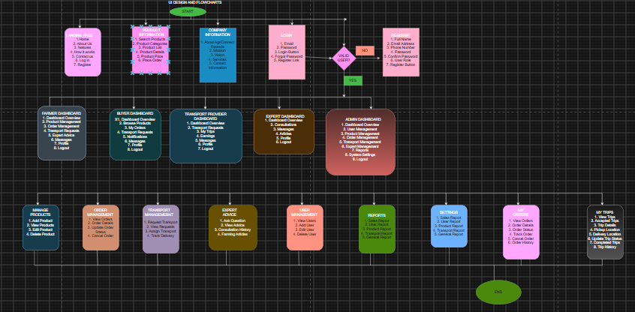

    - Database design with ERD and relationships
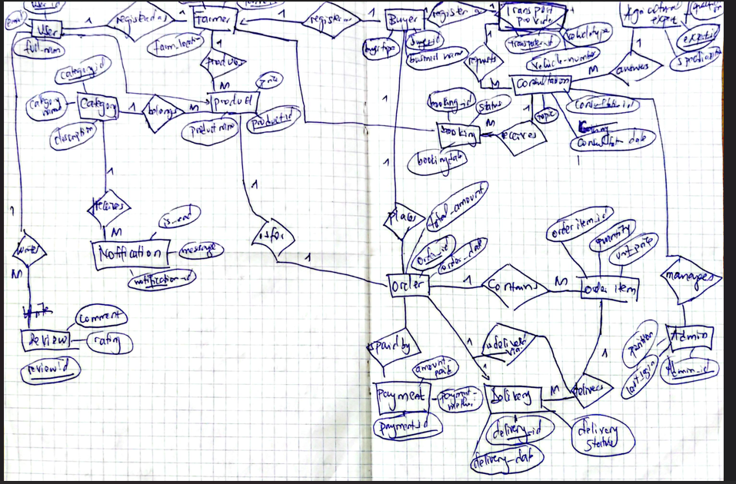

Chapter 3. Implementation
3.1 Introduction
This chapter explains how AgriConnect Rwanda was developed using HTML, CSS, JavaScriptand MySQL.
3.2 System Screenshots
3.2.1HOME PAGE
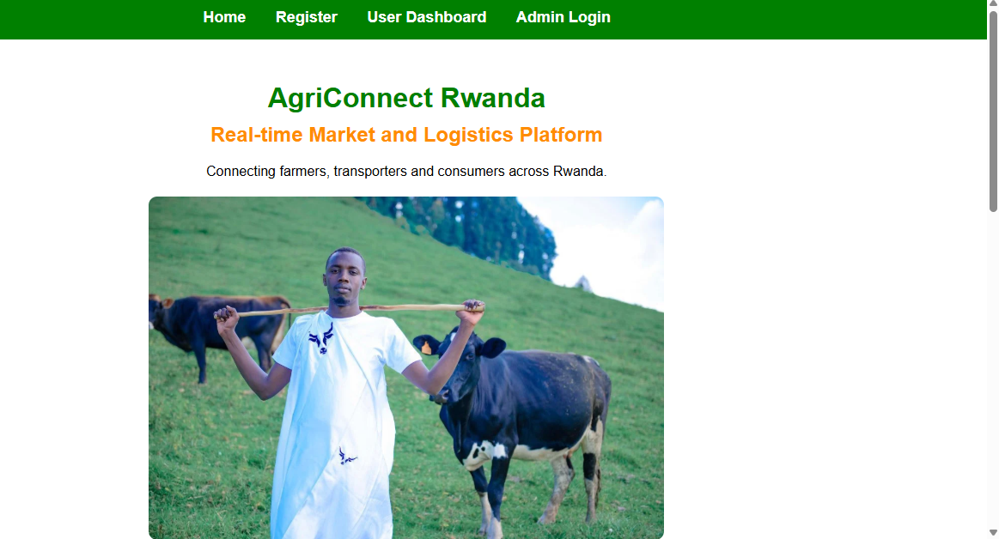
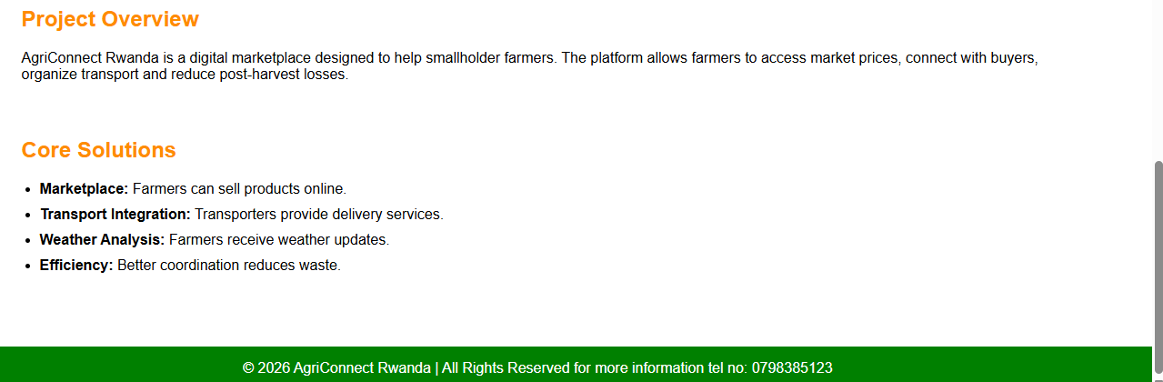
3.2.2REGISTER INFORMATION
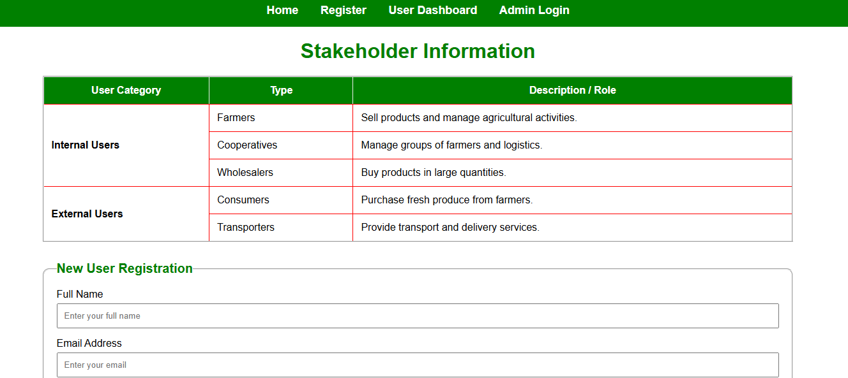

3.2.3USER DASHBOARD
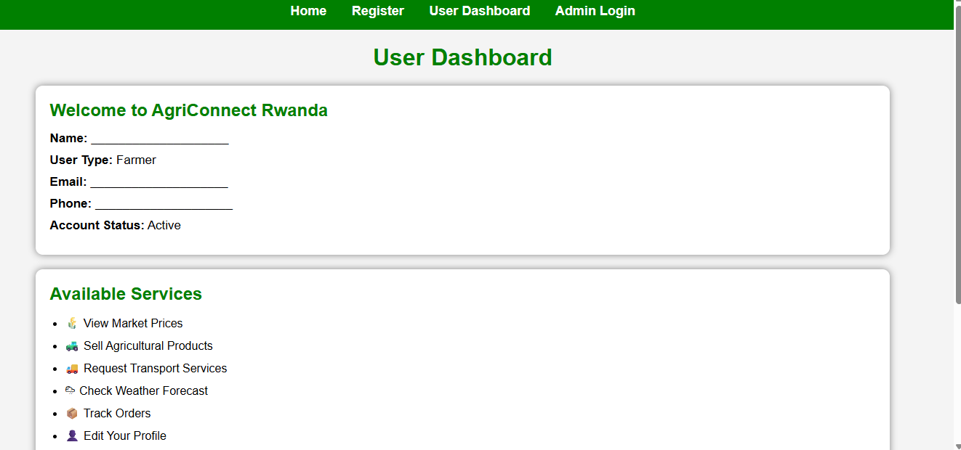

3.2.4ADMIN LOGIN
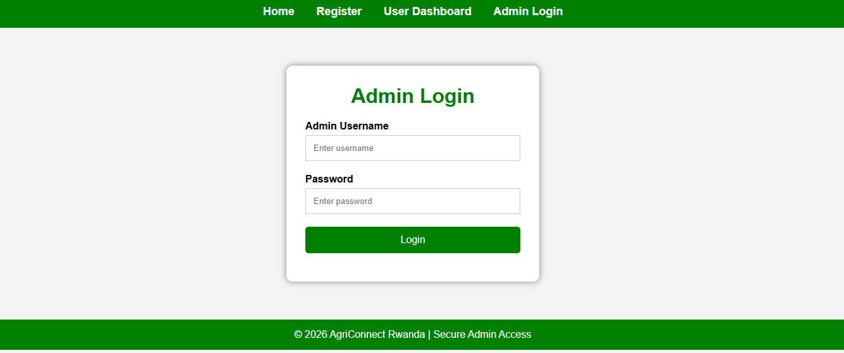

Chapter 4. Conclusion and Recommendation
4.1 Conclusion
AgriConnect Rwanda successfully achieved its main objective of connecting farmers, buyers, transport providers, and agricultural experts through a web-based platform. The system improves communication, market access, product management, and transport coordination. It demonstrates how web technologies can help modernize agriculture in Rwanda.
4.2 Recommendations
- To the Lecturer: Continue encouraging practical web development projects.
- To the University: Provide more time and resources for project development.
- To Farmers and Partners: Adopt the system to improve agricultural business.
- To Users: Attend training to understand how to use the platform effectively.
- For Future Development: Add online payment, mobile application support, and real-time notifications.

Appendix.
- • GitHub Repository Link : https://amiel88.github.io/Agriconnect/
- • GitHub Username :Amiel88
- • Project Name: AgriConnect Rwanda
- • Technologies Used:
- HTML
- CSS
- JavaScript

